**Assignment 2**

Create an AWS ECR Repository:

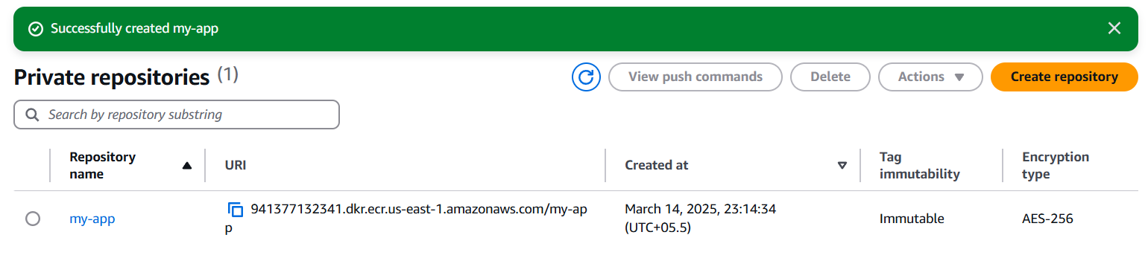

Set Up an AWS EC2 Instance:

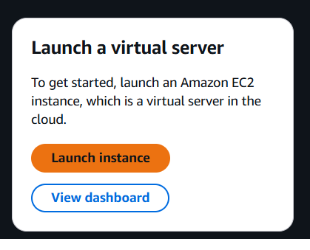

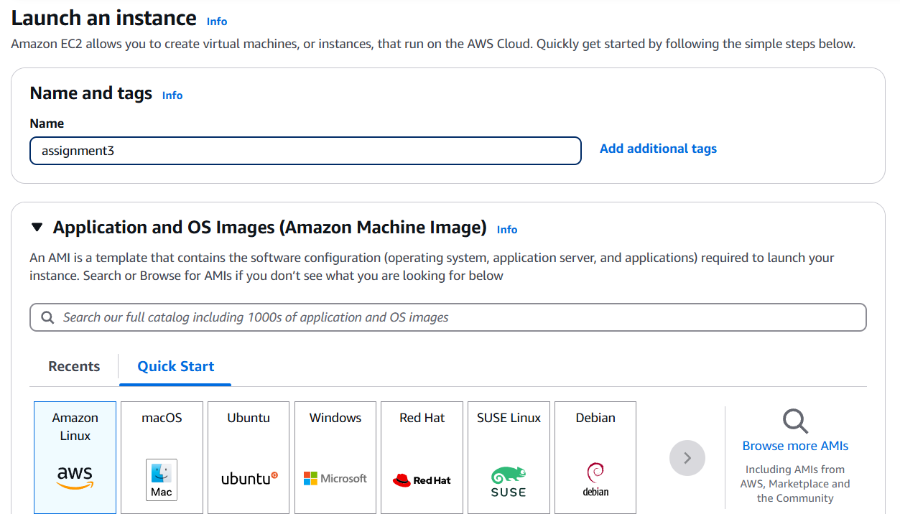

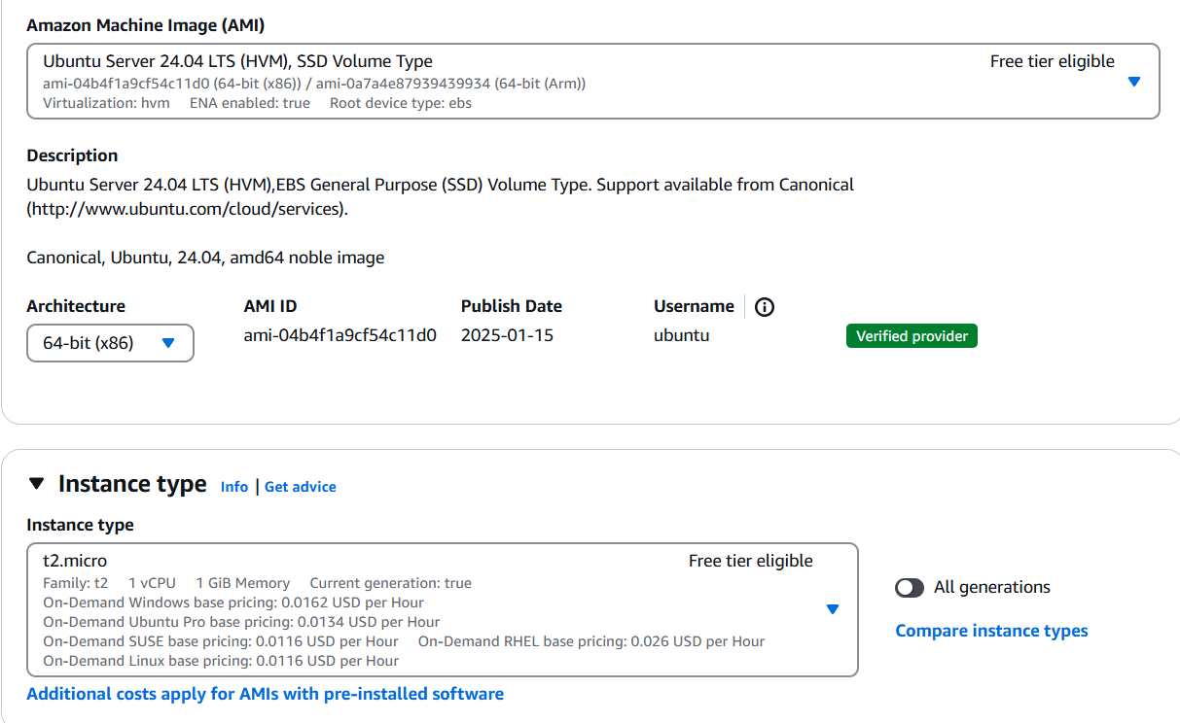

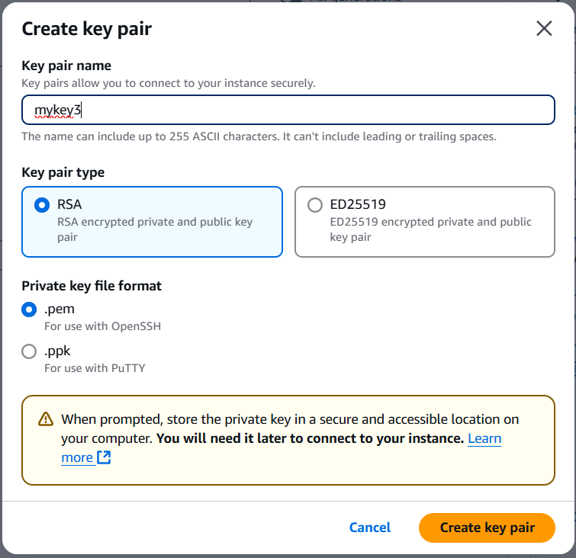

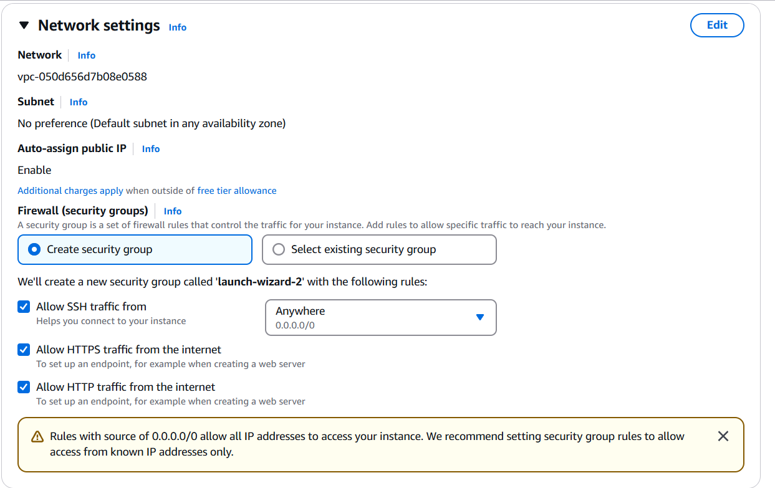

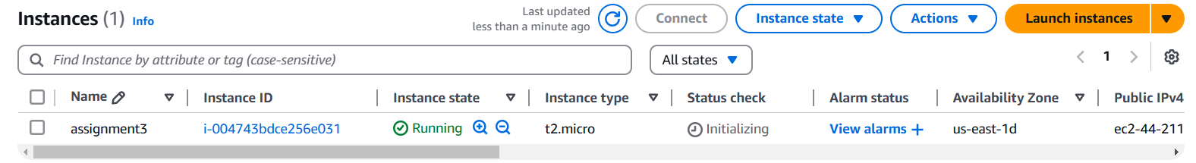

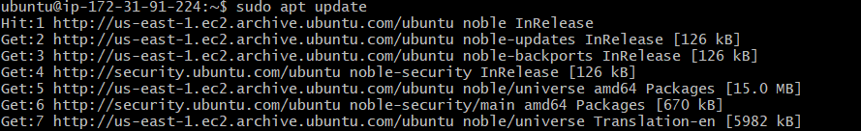

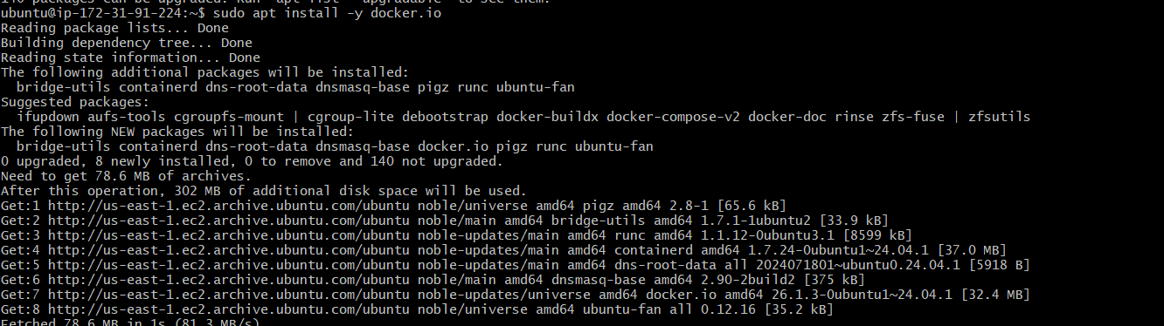





Configure IAM Permissions:

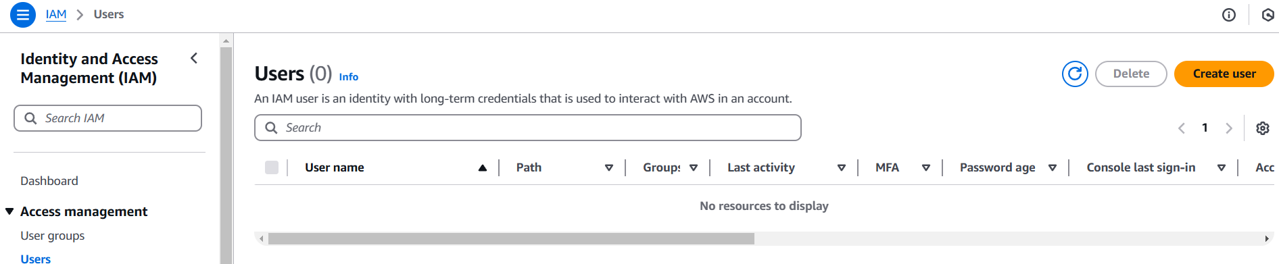

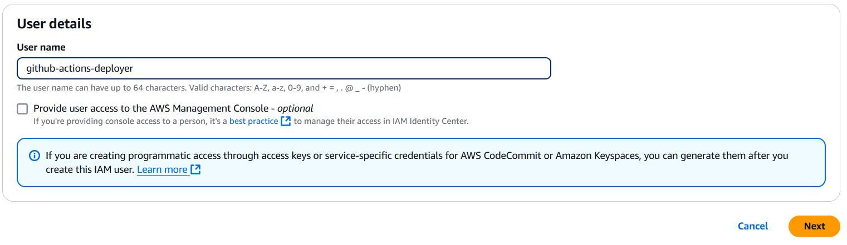

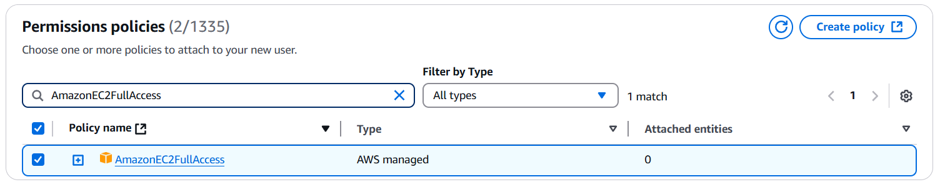

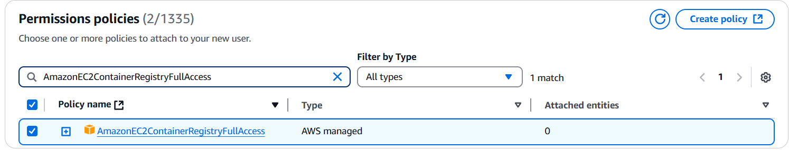

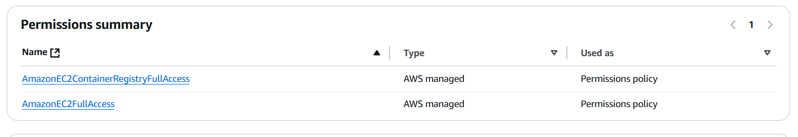

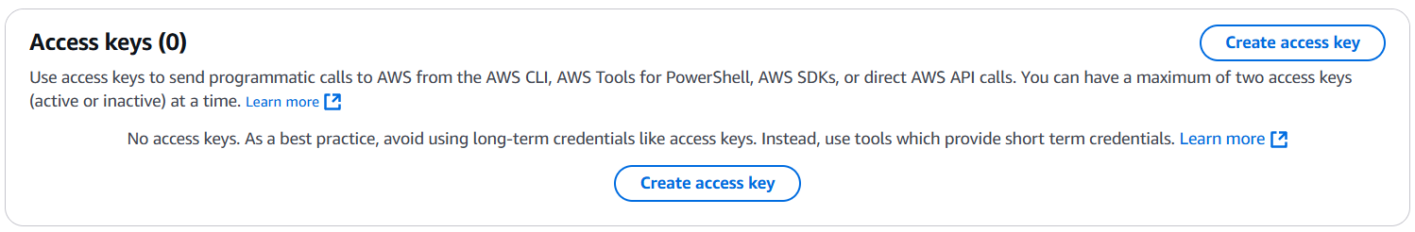

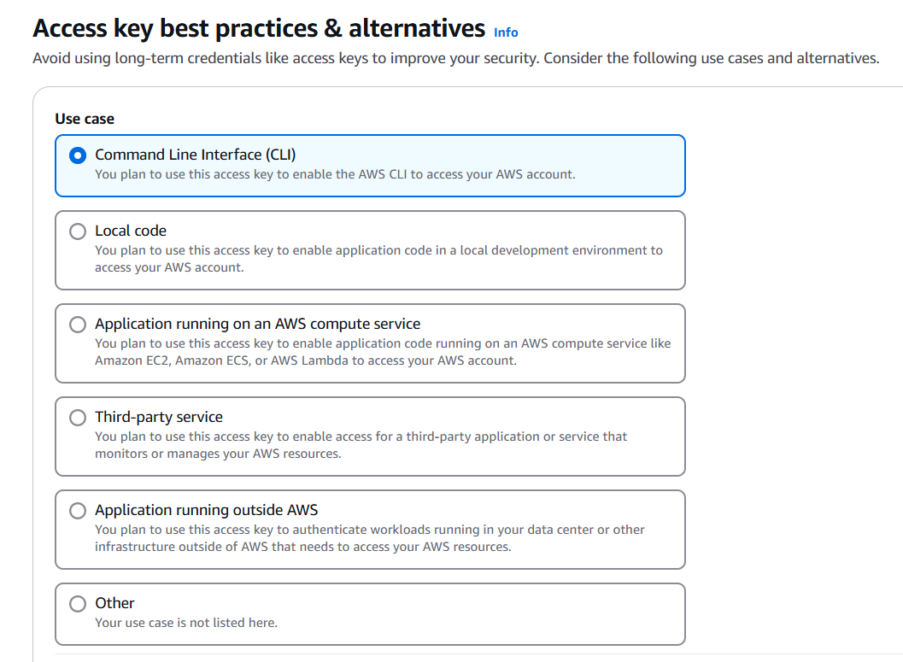

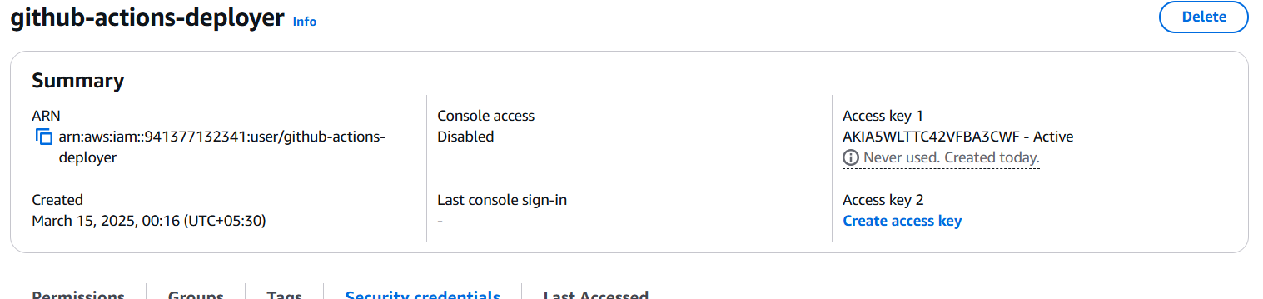

Store AWS Credentials in GitHub Secrets:

Add the following secrets:

* AWS_ACCESS_KEY_ID
* AWS_SECRET_ACCESS_KEY
* AWS_REGION (e.g., us-east-1)
* ECR_REPOSITORY (your ECR repo URI)
* EC2_HOST (your EC2 public IP)
* EC2_USER (usually ubuntu)
* EC2_SSH_KEY (your private SSH key, stored as a multi-line value)

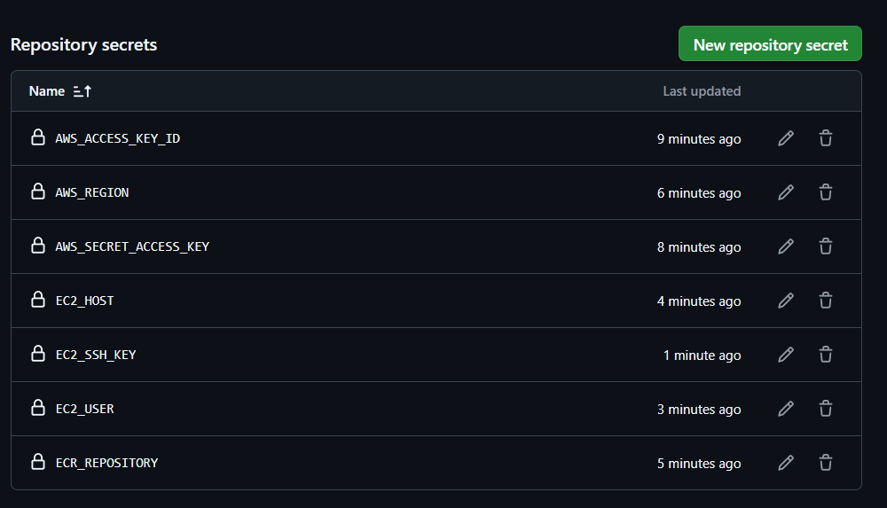

Prepare Your GitHub Repository:

* dev.yaml
* staging.yaml
* prod.yaml

